**Assignment 2**

**200088D**

**K.H.T.Chathumina**

|  |  |  |  |  |  |  |  |  |
| --- | --- | --- | --- | --- | --- | --- | --- | --- |
| State | Expected utility for taking each action | | | | | Best action | Expected utility for best action | Updated utility |
|  | North | East | South | West | Nothing |
| 1 | -0.09 | -0.005 | 0 | -0.005 | 0 | Nothing | 0 | -0.1 |
| 2 | -0.095 | -0.005 | -0.005 | -0.095 | 0 | Nothing | 0 | -0.1 |
| 3 | - | - | - | - | - | Nothing | - | 1 |
| 4 | 0 | 0 | 0 | 0 | 0 | Nothing | 0 | -0.1 |
| 5 | -0.005 | 0 | -0.005 | -0.09 | 0 | Nothing | 0 | -0.1 |
| 6 | -0.005 | 0 | -0.005 | -0.09 | 0 | Nothing | 0 | -0.05 |
|  | | | | | | | | |
| 1 | -0.1899 | -0.105 | -0.1 | -0.105 | -0.1 | Nothing | -0.1 | -0.1999 |
| 2 | -0.0994 | 0.8873 | -0.05 | -0.1927 | -0.1 | East | 0.8873 | 0.7864 |
| 3 | - | - | - | - | - | Nothing | - | 1 |
| 4 | -0.1 | -0.1 | -0.1 | -0.1 | -0.1 | East | -0.1 | -0.1999 |
| 5 | -0.1025 | -0.055 | -0.025 | -0.1899 | -0.1 | South | -0.025 | -0.1549 |
| 6 | -0.0552 | 0.0025 | 0.8898 | -0.092 | -0.05 | South | 0.8898 | 0.8389 |
|  | | | | | | | | |
| 1 | -0.204 | 0.6848 | -0.1506 | -0.2029 | -0.1999 | East | 0.6848 | 0.5841 |
| 2 | 0.6964 | 0.9736 | 0.7869 | 0.5993 | 0.7864 | East | 0.9736 | 0.8726 |
| 3 | - | - | - | - | - | Nothing | - | 1 |
| 4 | -0.1977 | -0.1594 | -0.1977 | -0.1999 | -0.1999 | East | -0.1594 | -0.2593 |
| 5 | -0.1105 | 0.7865 | 0.7367 | -0.2018 | -0.1549 | East | 0.7865 | 0.6858 |
| 6 | 0.8312 | 0.8469 | 0.9762 | 0.7091 | 0.8389 | South | 0.9762 | 0.9253 |

*Expected utility for 3rd state is not calculated because it is the terminal state and its value does not change.

**Best policy for each square after 3 iterations.**

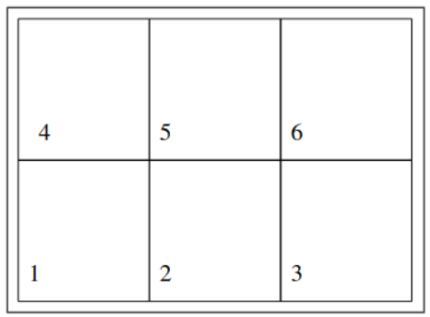

Do Nothing

South

East

East

East

East

**Best policy at the end.**

**On what iteration does the policy converge?** 3rd iteration

**How many iterations does it take the utilities to converge?** 10 iterations